# Summary of Recalibration Efforts for the Winter-Run Chinook Salmon SIT DSM (v2019)

## Rationale for Recalibration

We identified two primary concerns in the published versions of the SIT DSMs (i.e., those used in Peterson and Duarte 2019; e.g., available at [CVPIA-OSC/winterRunDSM at main (github.com)](https://github.com/CVPIA-OSC/winterRunDSM/tree/main)) that merited re-calibration of core model parameters. First, values for total diversions in the Upper Sacramento, which influence expected rearing survival, were incorrectly calculated as proportional diversions. Second, when the model is run in the deterministic mode, size class-specific survival terms are incorrectly applied for fish rearing in migratory corridors (e.g., Upper-mid, Lower-mid, Lower Sacramento River); because deterministic model runs serve as the basis for model calibration, this issue was especially problematic for comparing old and new model outputs. Both of these concerns led us to recalibrate the winter-run DSM for application in LTO modeling efforts.

## Methods for Winter-Run DSM

We created a new DSM folder for calibration efforts within the LTO-DSM-Wrapper repository, titled ‘winterRunDSM-Main_Calibration’ and based in part on the ‘winterRunDSM-Main’ workflow we previously developed for LTO modeling. We modified the following functions to accurately apply rearing survival across age classes and watersheds: Delt.rearfunc() and rearfunc() (in the R scripts ‘Delta juvenile growth n survival.R’ and ‘Survive and grow.R’, respectively). We also generated accurate values for total diversions in the Upper Sacramento River using the original CalSim input data and the R script ‘Create new t.diver for calibration.R’. Finally, we also removed previous scalar adjustments to spawning and rearing habitat quantities for all watersheds.

We conducted recalibration using the GA package in R (v4.2.0) We used the same calibration model inputs used in the original calibration effort using the cvpiaCalibration package ([FlowWest/cvpiaCalibration (github.com)](https://github.com/FlowWest/cvpiaCalibration)), with two exceptions: we used updated spawner abundance data from the Upper Sacramento River for brood years 1998-2017 and applied the updated total diversion values for the Upper Sacramento River watershed. Calibration model inputs were generated for 1998-2017 by constructing a synthetic time series of water years – see Peterson and Duarte (2019) for additional details. A total of 16 model parameters were estimated (Table 1). We ran the calibration-version of the model for the simulated period 1998-2016 (i.e., 19 years of spawner abundance data). Estimated model fit was calculated as the sum of squared differences between observed and model-estimated spawner abundance data over the modeled time series; we set the GA optimization to maximize the negative sum of squared differences.

Following exploratory rounds of calibrations with different optimization parameters and parameter constraints, we applied the following GA optimization parameters for the final calibration, drawing from recommendations from: [Winter Run Calibration 2021 • winterRunDSM (cvpia-osc.github.io)](https://cvpia-osc.github.io/winterRunDSM/articles/calibration-2021.html): popSize=100, maxiter=10000, run=50, pmutation=0.4. We used the original calibrated parameter values as starting values during optimization. We also set some informed constraints on possible values parameters. The adult en route survival parameter was bounded on the lower end at 0 to prevent unrealistically low survival values. Similarly, the last four parameters were bounded on the lower end at 0 based on expectations for the direction of covariate effects (e.g., survival should decrease with increased diversions). We bounded logit-transformed ocean survival to a maximum of -2 (i.e., we would not expect total marine survival, from ocean entry to freshwater return as spawners, to exceed 12%). All other parameter values were constrained with a default of -3.5 and 3.5 because all were expressed as logit-transformed values. Recalibration efforts were informed in part by consultation with the researchers who conducted the original calibration efforts (J. Peterson and A. Duarte, personal communication).

To assess the robustness and reliability of calibration results, we conducted multiple rounds calibration runs for each set of calibration parameters and compared both convergence model fit (i.e., the negative sum of squared differences) and parameter values among runs. The intent of this step is to investigate the possibility for local minima in optimization, evaluate whether parameter values were running up against constraints, and assess consistency in parameter estimates; ideally, most to all parameters should be generally similar among runs and should not be close to parameter constraints. If this assessment does not reveal obvious issues, we then used the parameter estimates from the calibration run with the best (highest) model fit as the final selected parameter values.

We also performed post-hoc tests for goodness of fit with the selected parameter values by generating model estimates of natural spawners for both the new and original parameter values and comparing these model estimates to historical estimates of spawner abundance used to calibrate the model.

Table 1. Parameters recalibrated for the winter-run Chinook salmon SIT DSM.

|  |  |  |
| --- | --- | --- |
| Parameter ID | Description | Notes |
| 1 | Juvenile in-channel and floodplain rearing survival intercept |  |
| 2 | Juvenile bypass rearing survival intercept |  |
| 3 | Juvenile Delta rearing survival intercept | Might expect negative covariance with Parameter 16 (Delta diversions effect on rearing survival) |
| 4 | Juvenile San Joaquin migratory survival intercept | Not relevant to winter-run - expect no consistent values among runs |
| 5 | Juvenile Sacramento River migratory survival intercept (temperature model) | Expect these two to covary |
| 6 | Juvenile Sacramento River migratory survival intercept (discharge model) |
| 7 | Juvenile Delta migratory survival intercept (flow model) | Expect these three to covary |
| 8 | Juvenile Delta migratory survival intercept (temperature model) |
| 9 | Juvenile Delta migratory survival intercept (diversion model) |
| 10 | Juvenile ocean entry survival intercept | Expect this one to be < -2 (max of 0.12 overall marine survival) |
| 11 | Adult en route survival intercept |  |
| 12 | Egg-to-fry survival intercept |  |
| 13 | Effect of contact points on juvenile rearing survival |  |
| 14 | Effect of proportion flow diverted on juvenile rearing/migratory survival |  |
| 15 | Effect of total flow diverted on juvenile rearing/migratory survival |  |
| 16 | Effect of Delta diversions on juvenile rearing survival |  |

## Results

### Overview

The results are separated into sections by the optimization settings, parameter constraints, and length of data time series; all but one set of calibration runs were used to finalize calibration methods or validate selected parameter constraints. Based on these results and our criteria for calibration success, we feel confident selecting the parameters from ‘run 3’ from the final set of calibration runs (i.e., long time series, standard marine survival constraint) as the new parameters for the winter-run DSM and using these values to compare the effects of competing alternatives on the winter-run population.

### Preliminary Calibration Results, Short Time Series (1998-2010), No Marine Survival Constraints

Before settling on the parameterization for the GA optimization discussed above, we conducted several rounds of exploratory calibration to identify potential issues. First, we ran the calibration with all described parameter constraints except that for marine survival (i.e., parameter 10, Table 1). For marine survival intercept, we applied the default constraints of -3.5 and 3.5. With these constraints, we ran three calibrations with a popSize=10 and two calibrations with a popSize=100. For these calibration runs, we used a short time series of spawner abundances from 1998-2010. We obtained the following takeaways from these efforts:

* Model fit values varied widely among runs, both with a popSize=10 and a popSize=100; we expect less variability and improved calibration performance with greater popSize values (Fig. 1). Variability in observed model fit suggests optimization routines are finding numerous, different local minima.
* Calibrated parameter values varied widely among runs, both with a popSize=10 and a popSize=100 (Fig. 2).
* The parameter for juvenile ocean entry survival intercept (Parameter ID = 10) both varied widely and was estimated to have implausibly high values (Fig. 2). Recent estimates of marine survival, encompassing ocean entry as smolts to age-2, were 0.23 or lower for late-fall-run Chinook salmon (Michel 2019); these values suggest survival from ocean entry to spawning as age-3 or age-4 fish is even lower, as annual natural mortality rates for age-3 fish are assumed to be 0.2 in winter-run Chinook salmon cohort reconstructions and forecasts (O’Farrell et al. 2016). Given most winter-run Chinook salmon spawn at age-3, we would expect the expected maximum marine survival to be in the ballpark of 0.184 (0.23 * 0.8) and average marine survival to be lower; these calculations do not account for any additional fishing mortality. With some runs, the marine survival parameter value was as high as 1.31, which translated to baseline marine survival of 0.79.

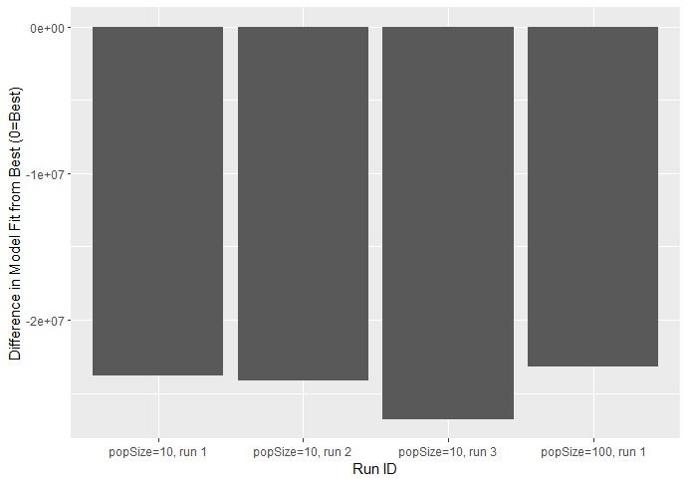

Figure 1. Comparison of differences in model fit for all sub-optimal models from the best model. The best model was *popSize=100, run=*2 and had a model fit of -146618423, or -1.47e8.

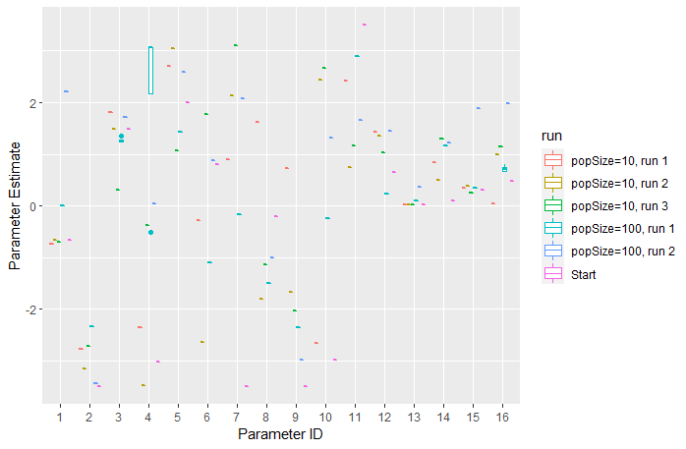

Figure 2. Plot of parameter estimates for 5 exploratory runs without constraints on marine survival intercept and a short calibration time series, as well the starting values drawn from the parameter values from the original calibration.

### Preliminary Calibration Results, Short Time Series (1998-2010), Marine Survival Constraints

We conducted another round of preliminary calibrations with the short time series of historical, or ‘known’, abundances after constraining marine survival to be less than 0.119 (logit-transformed value of -2); this value was based on a maximum observed marine survival to age-2 of 0.23 and expected natural mortality values for age-3 fish (see above text; O’Farrell et al. 2016; Michel 2019). With this new constraint, we ran three calibrations with a popSize=100. These efforts resulted in the following observations:

* Although there was still variability in metrics of model fit among model runs, the total difference was an order of magnitude smaller than that observed without constraints on marine survival (Fig. 3)
* We observed reasonably consistent estimates for most parameters among the three calibration runs (Fig. 4). In particular, logit-transformed estimates of marine survival were broadly similar without running into upper or lower boundaries. Some parameters, notably parameter estimates for San Joaquin River migratory survival and juvenile Delta migratory survival (i.e., parameters 4, 7-9) were highly variable among runs; however, San Joaquin River survival is expected to have no effect on population dynamics for winter-run Chinook salmon and the Delta survival parameters are expected to covary strongly because the three covariate hypotheses are equally weighted.
* We selected the parameters from ‘run 2’ and generated model estimates of spawner abundance to compare with ‘known’ spawners (Fig. 5). Although the newly calibrated parameter values provide better estimates of spawner abundance than the original values, the combination of the model structure and parameter values does not meaningfully account for observed variability in ‘known’ abundances.

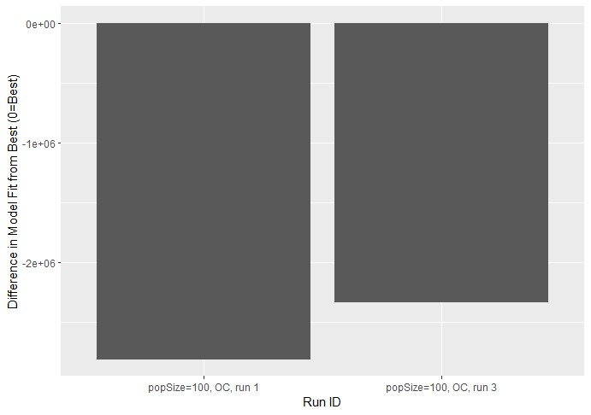

Figure 3. Comparison of differences in model fit for all sub-optimal models from the best model. The best model was *popSize=100, OC, run=*2 and had a model fit of -171165739, or -1.71e8.

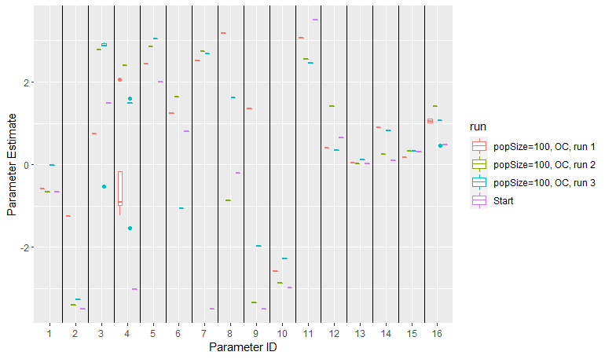

Figure 4. Plot of parameter estimates for 3 calibration runs with constraints on marine survival intercept and the short calibration time series, as well the starting values drawn from the parameter values from the original calibration.

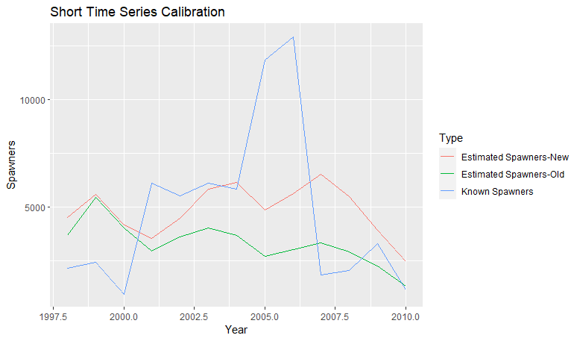

Figure 5. Plot of estimated spawners, both with original and newly calibrated parameter estimates, and known spawner abundances with the short time series of calibration data and informed constraints on marine survival.

### Final Calibration Results, Full Time Series (1998-2016), Marine Survival Constraints

We conducted a final round of three calibration runs with informed constraints on marine survival and the full time series of ‘known’ abundances. From this we round of calibration runs we obtained the following conclusions:

* Although there was still variability in metrics of model fit among model runs, the total difference was an order of magnitude smaller than that observed without constraints on marine survival and less than half that observed with the short calibration data time series (Fig. 6).
* We observed reasonably consistent estimates for most parameters among the three calibration runs (Fig. 7). Logit-transformed estimates of marine survival were again broadly similar without running into upper or lower boundaries. Some parameters, again including parameter estimates for San Joaquin River migratory survival and juvenile Delta migratory survival (i.e., parameters 4, 7-9) were highly variable among runs, as expected.
* Finally, we are confident that the specified upper bound for marine survival (logit-value = -2) was not overly restrictive in model fitting, as we performed three additional validation calibrations with a less restrictive upper bound (logit-value = -1, proportional marine survival = 0.27). None of the estimated marine survival terms exceeded the previous boundary (Fig. 8).
* We selected the parameters from ‘run 3’ as our best model (i.e., see Figs. 6, 7) and generated model estimates of spawner abundance to compare with ‘known’ spawners (Figs. 9, 10). The newly calibrated parameter values provide better estimates of spawner abundance than the original values, and the combination of model structure and newly calibrated parameter values do a reasonable job of approximating trends in ‘known’ spawners. The R2 for known and newly model estimated abundances is 0.188.
* Based on these results and our criteria for calibration success, we feel confident selecting the parameters from ‘run 3’ as the new parameters for the winter-run DSM and using these values to compare the effects of competing alternatives on the winter-run population. The parameter values are presented in Table 2.

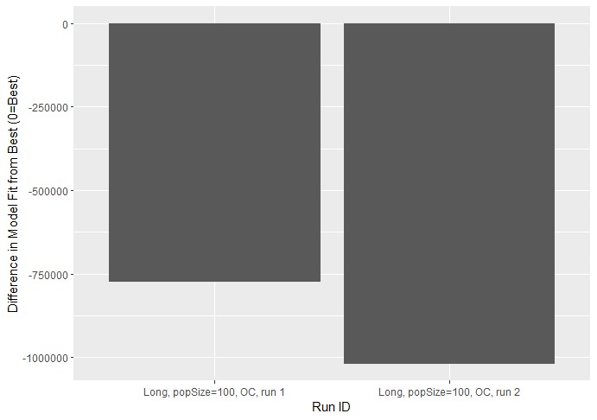

Figure 6. Comparison of differences in model fit for all sub-optimal models from the best model. The best model was *Long, popSize=100, OC, run=*3 and had a model fit of -179222734, or -1.79e8.

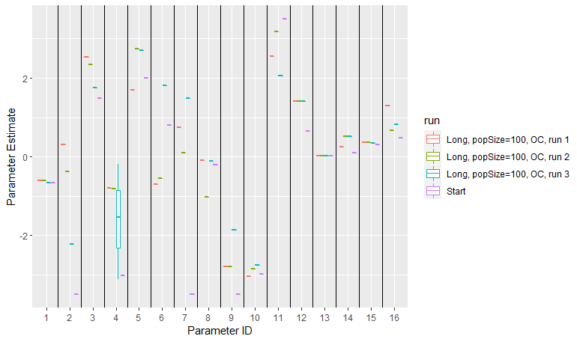

Figure 7. Plot of parameter estimates for 3 calibration runs with constraints on marine survival intercept and the full calibration time series, as well the starting values drawn from the parameter values from the original calibration.

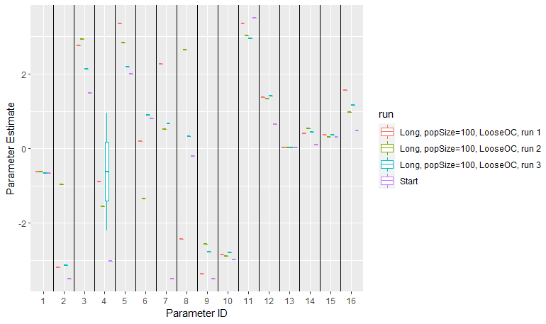

Figure 8. Plot of parameter estimates for 3 calibration runs with looser constraints on marine survival intercept (logit-transformed upper boundary = -1) and the full calibration time series, as well as the starting values drawn from the parameter values from the original calibration.

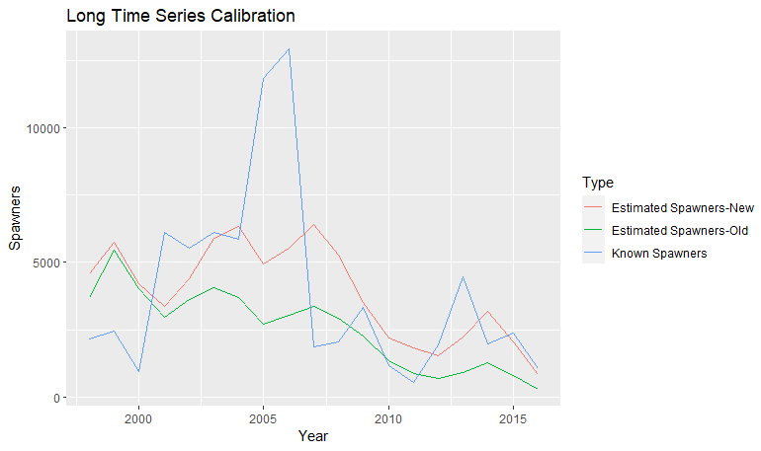

Figure 9. Plot of estimated spawners, both with original and newly calibrated parameter estimates, and known spawner abundances with the full time series of calibration data and informed constraints on marine survival.

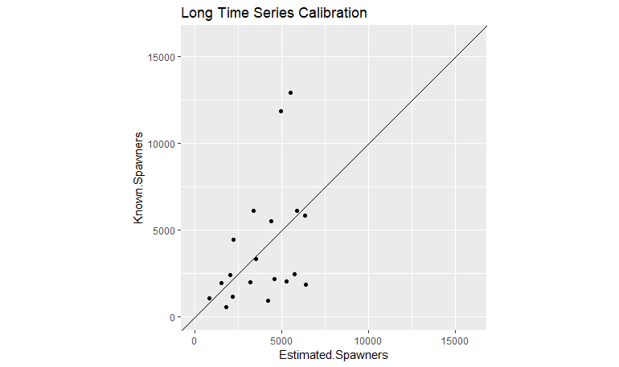

Figure 10. Scatterplot of estimated spawners with the newly calibrated parameter estimates and known spawner abundances with the full time series of calibration data and informed constraints on marine survival. A 1:1 line is provided for reference.

Table 2. Original and new parameter values for the winter-run DSM.

|  |  |  |  |
| --- | --- | --- | --- |
| Parameter ID | Description | Original Calibration Value | New Calibration Value |
| 1 | Juvenile in-channel and floodplain rearing survival intercept | -0.66 | -0.67 |
| 2 | Juvenile bypass rearing survival intercept | -3.5 | -2.23 |
| 3 | Juvenile Delta rearing survival intercept | 1.49 | 1.76 |
| 4 | Juvenile San Joaquin migratory survival intercept | -3.02 | -1.53 |
| 5 | Juvenile Sacramento River migratory survival intercept (temperature model) | 2.0 | 2.70 |
| 6 | Juvenile Sacramento River migratory survival intercept (discharge model) | 0.80 | 1.80 |
| 7 | Juvenile Delta migratory survival intercept (flow model) | -3.5 | 1.49 |
| 8 | Juvenile Delta migratory survival intercept (temperature model) | -0.2 | -0.11 |
| 9 | Juvenile Delta migratory survival intercept (diversion model) | -3.5 | -1.87 |
| 10 | Juvenile ocean entry survival intercept | -2.98 | -2.76 |
| 11 | Adult en route survival intercept | 3.5 | 2.06 |
| 12 | Egg-to-fry survival intercept | 0.65 | 1.41 |
| 13 | Effect of contact points on juvenile rearing survival | 0.02 | 0.02 |
| 14 | Effect of proportion flow diverted on juvenile rearing/migratory survival | 0.1 | 0.52 |
| 15 | Effect of total flow diverted on juvenile rearing/migratory survival | 0.3 | 0.35 |
| 16 | Effect of Delta diversions on juvenile rearing survival | 0.48 | 0.81 |

# Summary of Recalibration Efforts for the Spring-Run Chinook Salmon SIT DSM (v2019)

## Rationale for Recalibration

We identified the same two primary concerns in the published versions of the SIT DSMs (i.e., those used in Peterson and Duarte 2019; e.g., available at [CVPIA-OSC/winterRunDSM at main (github.com)](https://github.com/CVPIA-OSC/winterRunDSM/tree/main)) that merited re-calibration of core model parameters for the winter-run DSM in the spring-run DSM. First, values for total diversions in the Upper Sacramento, which influence expected rearing survival, were incorrectly calculated as proportional diversions. Second, when the model is run in the deterministic mode, size class-specific survival terms are incorrectly applied for fish rearing in migratory corridors (e.g., Upper-mid, Lower-mid, Lower Sacramento River); because deterministic model runs serve as the basis for model calibration, this issue was especially problematic for comparing old and new model outputs. Both of these concerns led us to recalibrate the spring-run DSM for application in LTO modeling efforts.

## Methods for Spring-Run DSM

We created a new DSM folder for calibration efforts within the LTO-DSM-Wrapper repository, titled ‘springRunDSM-Main_Calibration’ and based in part on the ‘springRunDSM-Main’ workflow we previously developed for LTO modeling. We modified the following functions to accurately apply rearing survival across age classes and watersheds: Delt.rearfunc() and rearfunc() (in the R scripts ‘Delta juvenile growth n survival.R’ and ‘Survive and grow.R’, respectively). We generated accurate values for total diversions in the Upper Sacramento River using the original CalSim input data and the R script ‘Create new t.diver for calibration.R’. Finally, we also removed previous scalar adjustments to spawning and rearing habitat quantities for all watersheds.

We conducted recalibration using the GA package in R (4.2.0). We used the same calibration model inputs used in the original calibration effort using the cvpiaCalibration package ([FlowWest/cvpiaCalibration (github.com)](https://github.com/FlowWest/cvpiaCalibration)), with three exceptions: 1) we used updated spawner abundance data from the Upper Sacramento River for brood years 1998-2017, 2) we included spawner abundance data from Battle Creek in calibration efforts, and 3) we applied the updated total diversion values for the Upper Sacramento River watershed. Calibration model inputs were generated for 1998-2017 by constructing a synthetic time series of water years – see Peterson and Duarte (2019) for additional details. A total of 29 model parameters were estimated (Table 3). We ran the calibration-version of the model for the simulated period 1998-2011 (i.e., 14 years of spawner abundance data). Estimated model fit was calculated as the sum of squared differences between observed and model-estimated spawner abundance data over the modeled time series for each of the following watersheds: Antelope Creek, Battle Creek, Butte Creek, Clear Creek, Deer Creek, Mill Creek, Feather River, and Yuba River. Only observed spawner abundance greater than 100 were included due to low count precision at small spawner abundances. The sum of squared differences for each watershed was then weighted by data availability (i.e., the number of years of acceptable spawner abundance data) and normalized by mean spawner abundance. We set the GA optimization to maximize the negative sum of squared differences, weighted and normalized, across all watersheds.

Following exploratory rounds of calibrations with different optimization parameters and parameter constraints, we applied the following GA optimization parameters for the final calibration effort, drawing from recommendations from: [Calibration • springRunDSM (cvpia-osc.github.io)](https://cvpia-osc.github.io/springRunDSM/articles/calibration.html): popSize=100, maxiter=10000, run=50, pmutation=0.4. We used the original calibrated parameter values as starting values during optimization with one exception: for Feather River marine survival, we set the initial value to 0 to fall within the specified parameter constraints. We also set informed constraints on possible values parameters. The adult en route survival parameter was bounded on the lower end at 0 to prevent unrealistically low survival values. Similarly, the last four parameters were bounded on the lower end at 0 based on expectations for the direction of covariate effects (e.g., survival should decrease with increased diversions). We bounded logit-transformed ocean survival for all watersheds to a maximum of 0 (i.e., we would not expect total marine survival to exceed 0.5); this value differed from the constraint on winter-run Chinook salmon to account for the yearling life history of spring-run and the high logit-transformed marine survival values for some watersheds in the original calibration (e.g., as high as logit-transformed value of 2.5, or proportional survival of 0.92). All other parameter values were constrained with a default of -3.5 and 3.5 because all were expressed as logit-transformed values. Recalibration efforts were informed in part by consultation with the researchers who conducted the original calibration efforts (J. Peterson and A. Duarte, personal communication).

To assess the robustness and reliability of calibration results, we conducted multiple rounds calibration runs for each set of calibration parameters and compared both convergence model fit (i.e., the negative sum of squared differences) and parameter values among runs. The intent of this step is to investigate the possibility for local minima in optimization, evaluate whether parameter values were running up against constraints, and assess consistency in parameter estimates; ideally, most to all parameters should be generally similar among runs and should not be close to parameter constraints. For the final round of calibration, with the parameters and constraints described above, we extracted parameter estimates from the calibration run with the best (highest) model fit as the final selected parameter values.

We also performed post-hoc tests for goodness of fit with the selected parameter values by generating model estimates of natural spawners for both the new and original parameter values and comparing these model estimates to historical estimates of spawner abundance used to calibrate the model.

Table 3. Parameters recalibrated for the spring-run Chinook salmon SIT DSM.

|  |  |  |
| --- | --- | --- |
| Parameter ID | Description | Notes |
| 1 | Juvenile in-channel and floodplain rearing survival intercept, Antelope Creek and other tributaries |  |
| 2 | Juvenile in-channel and floodplain rearing survival intercept, Deer Creek |  |
| 3 | Juvenile in-channel and floodplain rearing survival intercept, Mill Creek |  |
| 4 | Juvenile in-channel and floodplain rearing survival intercept, Feather River |  |
| 5 | Juvenile in-channel and floodplain rearing survival intercept, Yuba River |  |
| 6 | Juvenile in-channel and floodplain rearing survival intercept, Upper-mid/ Lower-mid/Lower Sacramento River |  |
| 7 | Juvenile in-channel and floodplain rearing survival intercept, Butte Creek |  |
| 8 | Juvenile in-channel and floodplain rearing survival intercept, San Joaquin River |  |
| 9 | Juvenile in-channel and floodplain rearing survival intercept, Battle, Clear Creek |  |
| 10 | Juvenile bypass rearing survival intercept |  |
| 11 | Juvenile Delta rearing survival intercept | Might expect negative covariance with Parameter 16 (Delta diversions effect on rearing survival) |
| 12 | Juvenile San Joaquin migratory survival intercept |  |
| 13 | Juvenile Sacramento River migratory survival intercept (discharge model) | Expect these two to covary |
| 14 | Juvenile Sacramento River migratory survival intercept (temperature model) |
| 15 | Juvenile Delta migratory survival intercept (flow model) | Expect these three to covary |
| 16 | Juvenile Delta migratory survival intercept (temperature model) |
| 17 | Juvenile Delta migratory survival intercept (diversion model) |
| 18 | Adult en route survival intercept |  |
| 19 | Juvenile ocean entry survival intercept - Antelope Creek and other tributaries | Expect this one to be < 0 (max of 0.5 overall marine survival) |
| 20 | Juvenile ocean entry survival intercept - Deer Creek | Expect this one to be < 0 (max of 0.5 overall marine survival) |
| 21 | Juvenile ocean entry survival intercept – Mill Creek | Expect this one to be < 0 (max of 0.5 overall marine survival) |
| 22 | Juvenile ocean entry survival intercept – Feather, Bear River | Expect this one to be < 0 (max of 0.5 overall marine survival) |
| 23 | Juvenile ocean entry survival intercept – Yuba River | Expect this one to be < 0 (max of 0.5 overall marine survival) |
| 24 | Juvenile ocean entry survival intercept – Butte Creek | Expect this one to be < 0 (max of 0.5 overall marine survival) |
| 25 | Juvenile ocean entry survival intercept – Battle, Clear Creek | Expect this one to be < 0 (max of 0.5 overall marine survival) |
| 26 | Effect of contact points on juvenile rearing survival |  |
| 27 | Effect of proportion flow diverted on juvenile rearing/migratory survival |  |
| 28 | Effect of total flow diverted on juvenile rearing/migratory survival |  |
| 29 | Effect of Delta diversions on juvenile rearing survival |  |

## Results

### Overview

The results are separated into sections by the optimization settings, parameter constraints, and length of data time series; only the last set of calibration runs was used to finalize calibration methods. Based on these results and our criteria for calibration success, we feel confident selecting the parameters from ‘run 3’ from the final set of calibration runs (i.e., marine survival constrained to be no greater than 0.5) as the new parameters for the spring-run DSM and using these values to compare the effects of competing alternatives on the spring-run population.

### Preliminary Calibration #1, popSize=10, Marine Survival < 0.5

We conducted a round of preliminary calibrations with a popSize=10 and marine survival constrained to be less than 0.5. We wanted to evaluate behavior of the calibrations with the proposed survival constraints before committing to a full-scale calibration with popSize=100. These efforts resulted in the following observations:

* There was noticeable variability in metrics of model fit among model runs, but it is difficult to interpret the magnitude of this variability without comparing to another set of similar calibration runs (Fig. 11). Metrics of model fit should not be compared between winter- and spring-run calibration attempts.
* We observed somewhat consistent estimates for most parameters among the three calibration runs (Fig. 12). Logit-transformed estimates of marine survival for each watershed were broadly similar among runs and did not appear to run into upper or lower bounds.
* Some parameters, notably parameter estimates for juvenile Delta and Sacramento River migratory survival (i.e., parameters 10-12, 14) were highly variable among runs; however, migratory survival parameters can be expected to covary strongly because multiple covariate hypotheses are equally weighted for both the Delta and Sacramento River.
* We selected the parameters from ‘run 3’ and generated model estimates of spawner abundance to compare with ‘known’ spawners (Fig. 13). Model estimates of spawner abundance appear to closely match observed spawner abundances from Butte Creek but more poorly reflect observed abundances from other systems. Given the greater spawner abundance from this system, this result is not unexpected. Estimates abundances were particularly biased low for Feather River and Yuba River; however, spawner estimates for these systems are based on combined spring- and fall-run counts separated using CWT data from 2010-2012, while estimates for all other systems were for spring-run only. The correlation between all estimated and observed abundances for 1998-2011 was 0.757, which compares favorably with the correlation of 0.8 reported in Peterson and Duarte (2020).

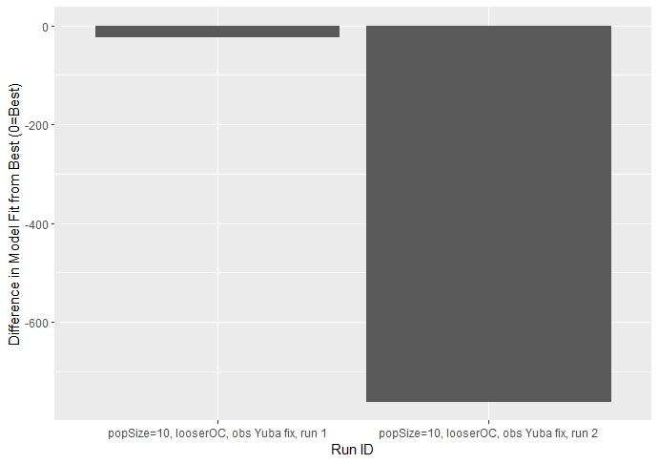

Figure 11. Comparison of differences in model fit for all sub-optimal models from the best model with *popSize=10*. The best model was *popSize=10, looserOC, obs Yuba fix, run=*3 and had a model fit of -10,404.

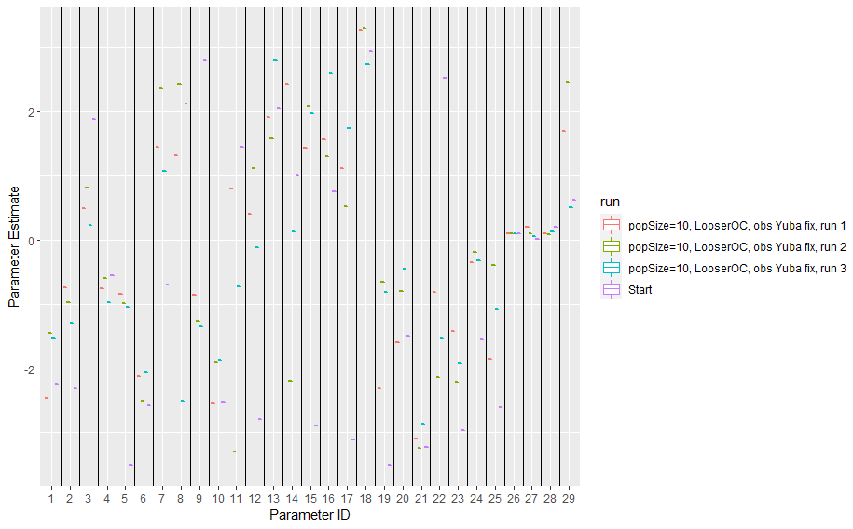

Figure 12. Plot of parameter estimates for 3 spring-run calibration runs with popSize=10, as well the starting values drawn from the parameter values from the original calibration.

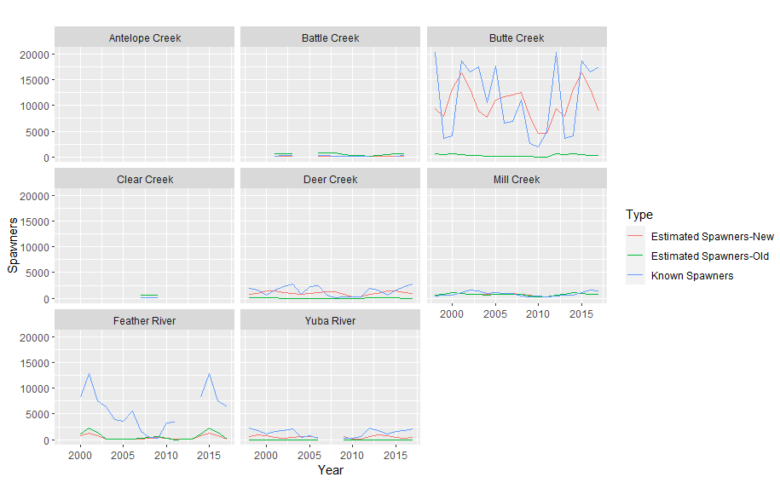

Figure 13. Plot of estimated spawners, both with original and newly calibrated parameter estimates, and known spawner abundances for the best preliminary calibration effort for spring-run Chinook salmon, presented for all watersheds that provided data to model calibration.

### Final Calibration, popSize=100, Marine Survival < 0.5

We conducted a final round of three calibration runs with a popSize=100 and marine survival constrained to be less than 0.5. From this final round of calibration runs we obtained the following conclusions:

* The variability in metrics of model fit among model runs was similar to that observed for preliminary calibration runs with popSize=10 (Fig. 14).
* We observed reasonably consistent estimates for most parameters among the three calibration runs (Fig. 15). Logit-transformed estimates of marine survival for each watershed were broadly similar among runs. In contrast to model runs with popSize=10, estimates of marine survival did not run into either upper or lower bounds.
* Some parameters, notably parameter estimates for juvenile rearing survival in the San Joaquin River (parameter 8) and Delta (parameter 11) and migratory survival in the Sacramento River (parameter 15) were more variable among runs; migratory survival parameters can be expected to covary strongly because multiple covariate hypotheses are equally weighted for the Sacramento River.
* We selected the parameters from ‘run 3’ as our best model and generated model estimates of spawner abundance to compare with ‘known’ spawners (Figs. 16, 17). Model estimates of spawner abundance again appear to closely match observed spawner abundances from Butte Creek but more poorly reflect observed abundances from other systems. Estimates abundances were particularly biased low for Feather River and Yuba River. The correlation between all estimated and observed abundances for 1998-2011 was 0.763, which again compares favorably with the correlation of 0.8 reported in Peterson and Duarte (2020); we note that we achieved this correlation without modifying habitat quantity scalars (i.e., artificially decreasing or increasing habitat quantity).
* Based on these results and our criteria for calibration success, we feel confident selecting the parameters from ‘run 3’ as the new parameters for the spring-run DSM and using these values to compare the effects of competing alternatives on the winter-run population. The parameter values are presented in Table 4.

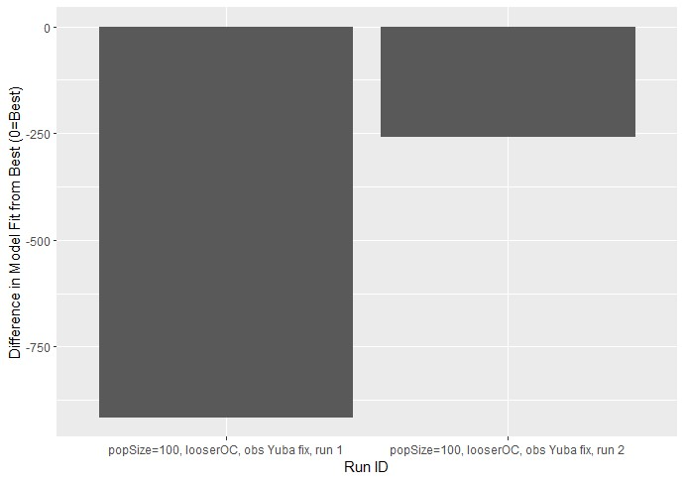

Figure 14. Comparison of differences in model fit for all sub-optimal models from the best model with *popSize=100*. The best model was *popSize=100, looserOC, obs Yuba fix, run=*3 and had a model fit of -9,981.

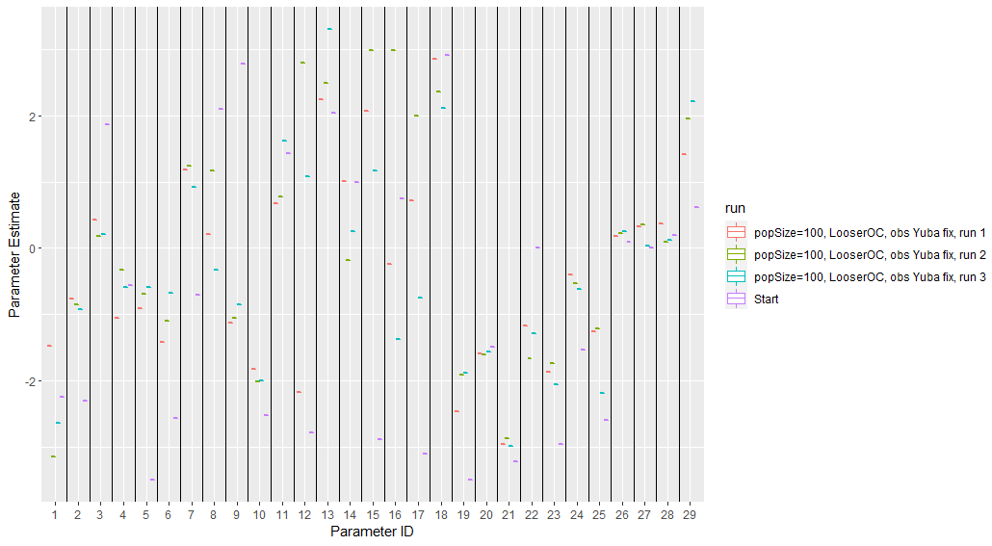

Figure 15. Plot of parameter estimates for 3 spring-run calibration runs with popSize=100, as well the starting values drawn from the parameter values from the original calibration.

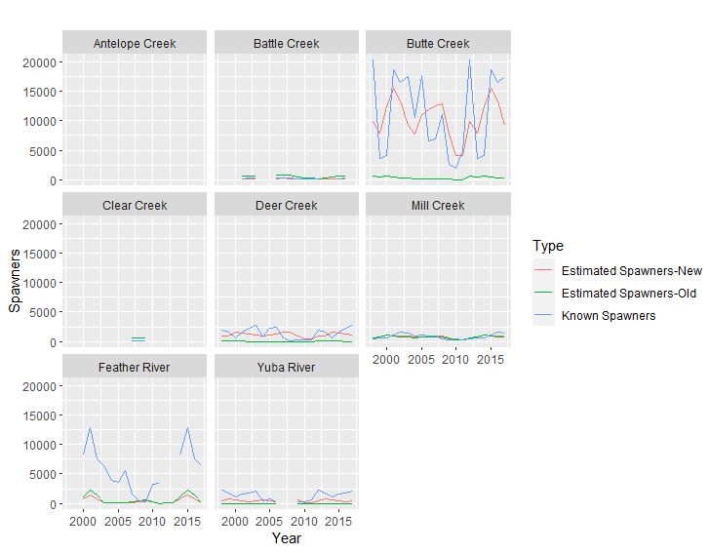

Figure 16. Plot of estimated spawners, both with original and newly calibrated parameter estimates, and known spawner abundances for the best final calibration effort for spring-run Chinook salmon, presented for all watersheds that provided data to model calibration.

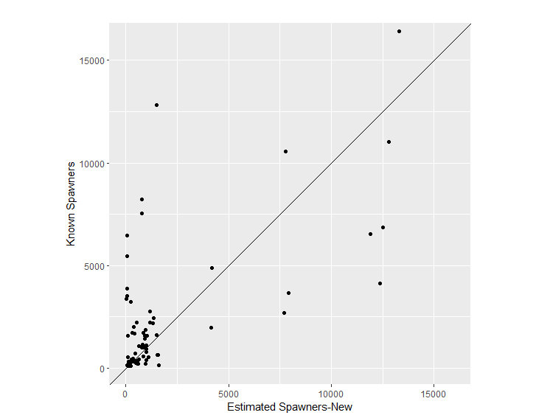

Figure 17. Scatterplot of estimated spring-run spawners with the newly calibrated parameter estimates and known spawner abundances for the selected parameter values from the final calibration efforts. A 1:1 line is provided for reference.

Table 4. Original and new parameter values for the spring-run DSM.

|  |  |  |  |
| --- | --- | --- | --- |
| Parameter ID | Description | Original Calibration Value | New Calibration Value |
| 1 | Juvenile in-channel and floodplain rearing survival intercept, Antelope Creek and other tributaries | -2.25 | -2.65 |
| 2 | Juvenile in-channel and floodplain rearing survival intercept, Deer Creek | -2.31 | -0.93 |
| 3 | Juvenile in-channel and floodplain rearing survival intercept, Mill Creek | 1.87 | 0.21 |
| 4 | Juvenile in-channel and floodplain rearing survival intercept, Feather River | -0.55 | -0.59 |
| 5 | Juvenile in-channel and floodplain rearing survival intercept, Yuba River | -3.5 | -0.60 |
| 6 | Juvenile in-channel and floodplain rearing survival intercept, Upper-mid/ Lower-mid/Lower Sacramento River | -2.57 | -0.67 |
| 7 | Juvenile in-channel and floodplain rearing survival intercept, Butte Creek | -0.71 | 0.93 |
| 8 | Juvenile in-channel and floodplain rearing survival intercept, San Joaquin River | 2.1 | -0.32 |
| 9 | Juvenile in-channel and floodplain rearing survival intercept, Battle, Clear Creek | 2.79 | -0.85 |
| 10 | Juvenile bypass rearing survival intercept | -2.52 | -2.00 |
| 11 | Juvenile Delta rearing survival intercept | 1.43 | 1.62 |
| 12 | Juvenile San Joaquin migratory survival intercept | -2.79 | 1.08 |
| 13 | Juvenile Sacramento River migratory survival intercept (discharge model) | 2.04 | 3.31 |
| 14 | Juvenile Sacramento River migratory survival intercept (temperature model) | 1 | 0.26 |
| 15 | Juvenile Delta migratory survival intercept (flow model) | -2.89 | 1.17 |
| 16 | Juvenile Delta migratory survival intercept (temperature model) | 0.75 | -1.37 |
| 17 | Juvenile Delta migratory survival intercept (diversion model) | -3.1 | -0.75 |
| 18 | Adult en route survival intercept | 2.92 | 2.12 |
| 19 | Juvenile ocean entry survival intercept - Antelope Creek and other tributaries | -3.5 | -1.88 |
| 20 | Juvenile ocean entry survival intercept - Deer Creek | -1.5 | -1.56 |
| 21 | Juvenile ocean entry survival intercept – Mill Creek | -3.23 | -3.00 |
| 22 | Juvenile ocean entry survival intercept – Feather, Bear River | 2.5 | -1.29 |
| 23 | Juvenile ocean entry survival intercept – Yuba River | -2.96 | -2.06 |
| 24 | Juvenile ocean entry survival intercept – Butte Creek | -1.54 | -0.62 |
| 25 | Juvenile ocean entry survival intercept – Battle, Clear Creek | -2.59 | -2.19 |
| 26 | Effect of contact points on juvenile rearing survival | 0.1 | 0.26 |
| 27 | Effect of proportion flow diverted on juvenile rearing/migratory survival | 0.01 | 0.03 |
| 28 | Effect of total flow diverted on juvenile rearing/migratory survival | 0.19 | 0.12 |
| 29 | Effect of Delta diversions on juvenile rearing survival | 0.61 | 2.22 |

# References

Michel, C.J. 2019. Decoupling outmigration from marine survival indicates outsized influence of streamflow on cohort success for California’s Chinook salmon populations. Canadian Journal of Fisheries and Aquatic Sciences 76: 1398-1410.

O’Farrell, M., Hendrix, N., and Mohr, M. 2016. An Evaluation of preseason abundance forecasts for Sacramento River winter Chinook salmon. Agenda Item D.2., Attachment 1.

Peterson, J.D., and Duarte, A. 2020. Decision analysis for greater insights into the development and evaluation of Chinook salmon restoration strategies in California’s Central Valley. Restoration Ecology 28(6): 1596-1609.